I will go to Dr. Lori Henderson’s office, a dentist for children.  I will follow directions. I will stay calm and be safe. I will tell someone if I need or want anything. | 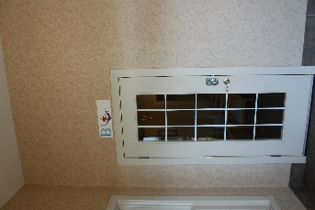  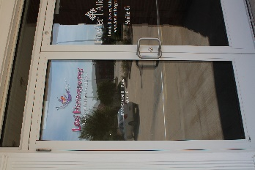
First, I check in at the front desk.  I have to tell them my name and sign in on an IPad. | 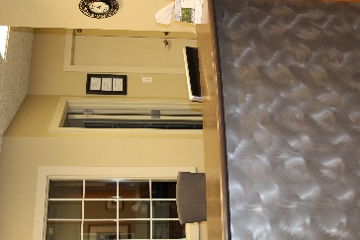
Next, I will wait in the waiting room for my name to be called.  I can play with toys or look at books while I wait. I will stay calm and safe in the waiting room. | 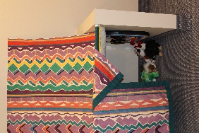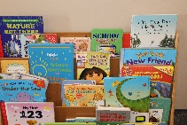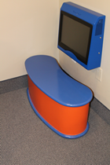
Then, I will go back to a room to talk to someone about my teeth.  I will sit in a special chair that moves and leans back. I have to sit still so the dentist can look at my teeth. | 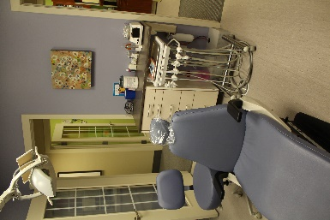
Next, the dentist may use special tools to count and clean my teeth. I will stay still in the chair. Dr. Lori will be very gentle.  I get to wear sunglasses to help protect my eyes.  I can use some toys to help me stay calm if I need them.  I can tell her if I need a break. | 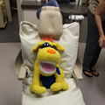  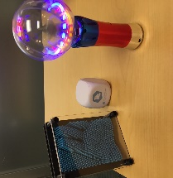
Dr. Lori may brush fluoride on my teeth. I will stay still in the chair. Dr. Lori will be very gentle.  I will get a sticker that says what time I can eat and drink again. | 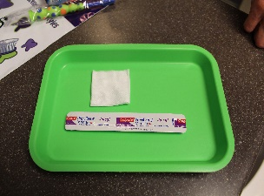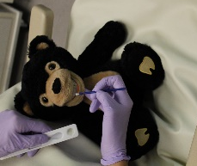
I might go to a room for an x-ray.  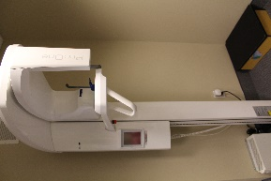  I will stay very still and only move when told to. The machine does not touch me. I will be comfortable. | 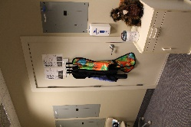
Then, the dentist will give me a bag with my very own toothbrush, toothpaste, and flossers to take home! | 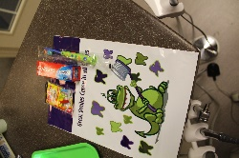
When I am finished, I get to get a toy from the machine!  Finally, I check out.  I am all done! | 